***20103153_avni_w10***

1)

#include <iostream>

using namespace std;

int main()

{

int a;

char b;

double c;

cout << "Enter an Integer: ";

cin >> a;

cout << "Enter a character: ";

cin >> b;

cout << "Enter a float: ";

cin >> c;

try

{

throw a;

}

catch (int)

{

cout << "integer value is inputed"<<endl;

}

try

{

throw b;

}

catch (char)

{

cout << "character value is inputed"<<endl;

}

try

{

throw c;

}

catch (double)

{

cout << "float value is inputed"<<endl;

}

return 0;

}

Output:

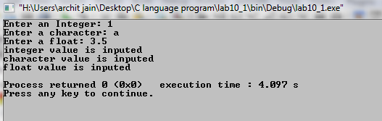

2)

Output:

Try block entered.

Exception thrown with

wait_time equal to 46

After catch block.

3)

Output:

Try block entered.

Leaving try block.

After catch block.

4)

Throw statement is used to throw exceptions to exception handler. This thrown statement is passed with an argument which is catched by the catch statement and thereby saving the malfunctioning of code due to errors while execution of the code.

5)

Trying.

Starting sample_function.

Catching.

End of program.

6)

Trying.

Starting sample_function.

Trying after call.

End of program.

7)

If an exception is not caught by catch block then the runtime system will abort the

Program and the program will be terminated there itself.

8)

YES, we can write nested try statements in our code.

9)

d) CaughtOne CaughtOne CaughtString CaughtOne

10)

a)

MyException caught

C++ Exception